Wordless Book Origin
A Wordless Book is a Christian evangelistic device. Evidence points to it being invented by the famous London Baptist preacher Charles Haddon Spurgeon, in a message given on January 11, 1866 to several hundred orphans regarding Psalm 51:7 "Wash me, and I shall be whiter than snow. " It is called a "book", as it is usually represented with pages, although it can be shown on a single page or banner. The book consists of several blocks of pure color that, in sequence, represent a nonverbal catechism for the instruction of children, the illiterate, or people of different cultures about basic Christian teachings. However, the presentation of the book is meant to be a verbal experience, providing the "reader" a visual cue to expound Christian doctrine extemporaneously or in impromptu situations.

Variations on a theme
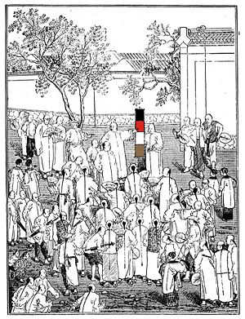  Open-air preaching in China using the Wordless Book | Spurgeon’s concept only contained three colors: “first was black, the second was red, and the third was pure white”  - Black: representing the “sinful state” of humanity “by nature”. Usually referred to as the dark page.  - Red: representing the blood of Jesus.  - White: representing the “perfect righteousness which God has given to believers through the atoning sacrifice of Jesus Christ his Son”.
By 1880 at least, the book was being widely used in evangelism among orphanages, Sunday schools, and in cross-cultural missions.
Different versions came about when Dwight Lyman Moody added another color: gold – representing Heaven in 1875. Hudson Taylor and missionaries of the China Inland Mission used the four color version in open-air preaching and individual evangelism. Modern versions include even more colors, such as green "to grow in the knowledge of God". It has been used by missionaries and teachers such as Jennie Faulding Taylor, Amy Carmichael, Fanny Crosby (who was blind), and modern day Child Evangelism Fellowship which added a fifth color: green - representing one's need to grow in Christ after salvation.

Color cosmology
The success of the Wordless Book in communicating with East Asian peoples is arguably due to the influence of "color cosmology" (wuxing)^{[5]} or color psychology in Chinese culture. For example, in Chinese symbolism, red is the color of good luck and success, and is used for decoration and wedding attire (during the traditional half of the wedding ceremony, while the bridal attire in the modern half is usually white). Money in Chinese societies is traditionally given in red packets; while white is the funeral color instead of black.

Two books published by Child Evangelism Fellowship under the title "The Wordless Book"
ISBN 9-90117-036-2 ISBN 9-90117-026-5

